Project Development Phase
Model Performance Test
Date | 30 September 2026
Team ID | SWTID-2026-7220
Project Name | Import Data using Transform Maps (Spreadsheet)
Maximum Marks | 10 Marks

Model Performance Testing
This project is primarily a ServiceNow data-management and automation solution rather than a machine-learning model. Therefore, model-training accuracy is not applicable. Performance is evaluated through import accuracy, transform behavior, coalesce matching, duplicate prevention and dashboard/report correctness.
S.No. | Parameter | Values | proof
1 | System / Solution Summary | ServiceNow Import Set + Transform Map solution for importing employee spreadsheet data into Employee Test. | Attach Import Set / Transform Map screen
2 | Data Import Accuracy | Initial test: 4 rows processed; 2 new Employee IDs inserted and 2 existing Employee IDs updated when Employee ID was used as Coalesce. | Attach Transform History
3 | Coalesce Verification | Employee ID configured as the unique Coalesce field. Re-importing the same 4 rows should avoid duplicate records. | Attach Field Map showing Coalesce = True
4 | Repeated Import Behavior | Second import of the same data: expected 0 new records, 0 updates and 4 ignored records, subject to the configured transform behavior. | Attach second Transform History
5 | Report / Dashboard Validation | Employee reports and Employee Analytics Dashboards display the imported Employee Test data by department, location and list. | Attach report/dashboard screenshots

Performance / Accuracy Notes
Because no predictive ML model is used in this ServiceNow project, Training Accuracy, Validation Accuracy, Confusion Matrix and Confidence Score are not applicable. The relevant accuracy measure is whether source records are correctly inserted, updated or ignored according to Employee ID matching.

Screenshots to Attach
1. Employee Import staging table containing the 4 imported rows.
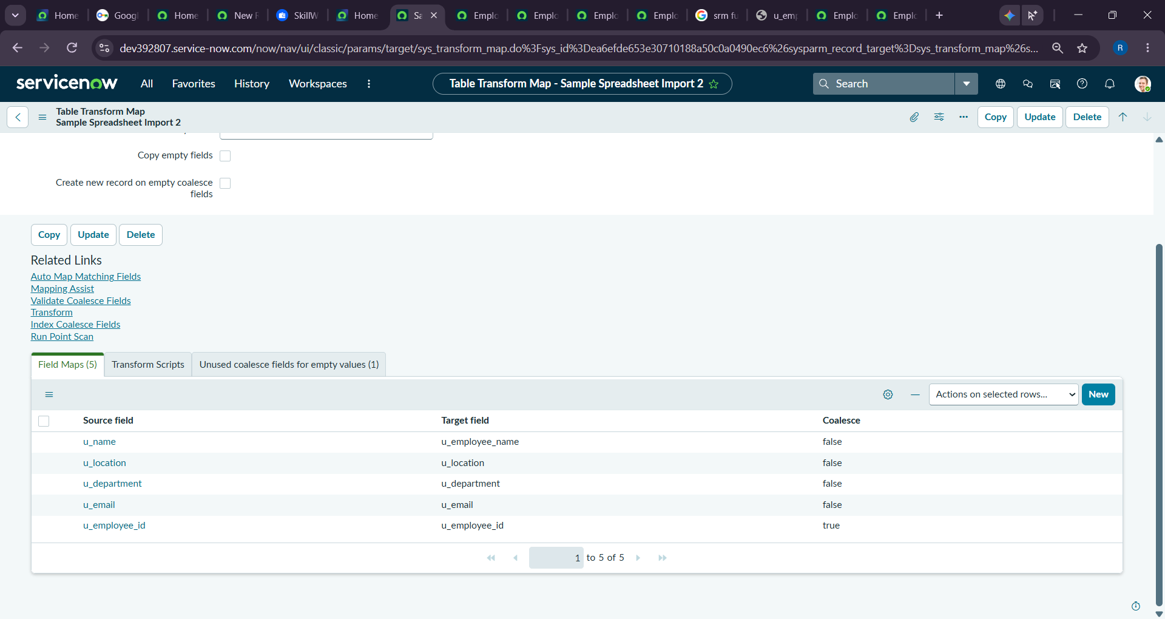
2. Sample Spreadsheet Import Transform Map.
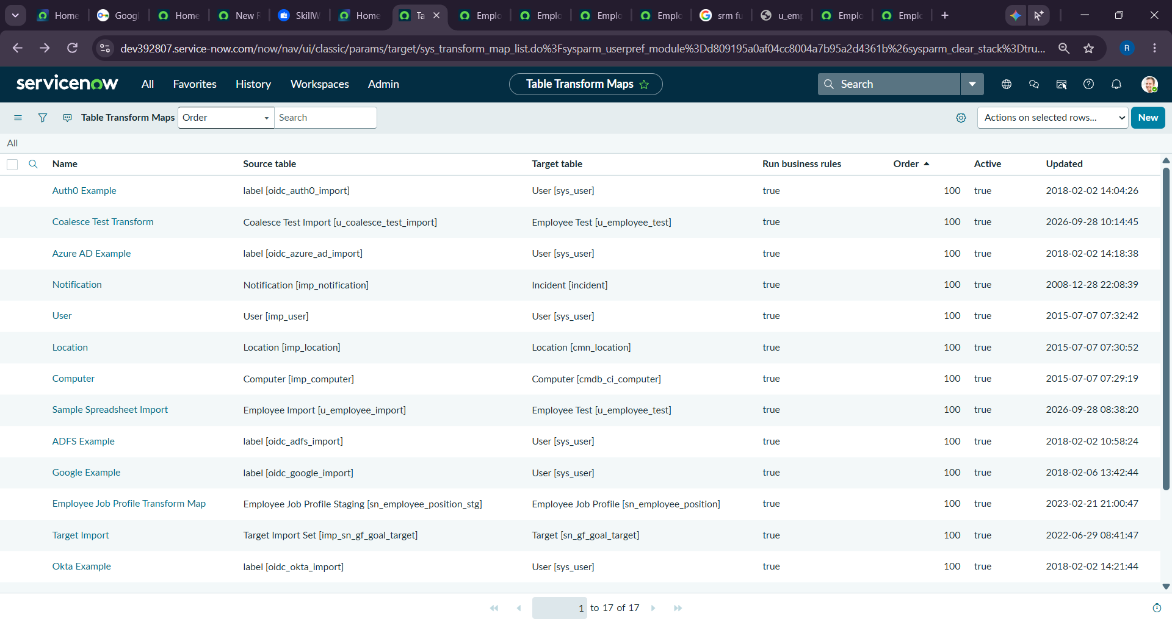
3. Employee ID field map with Coalesce enabled.
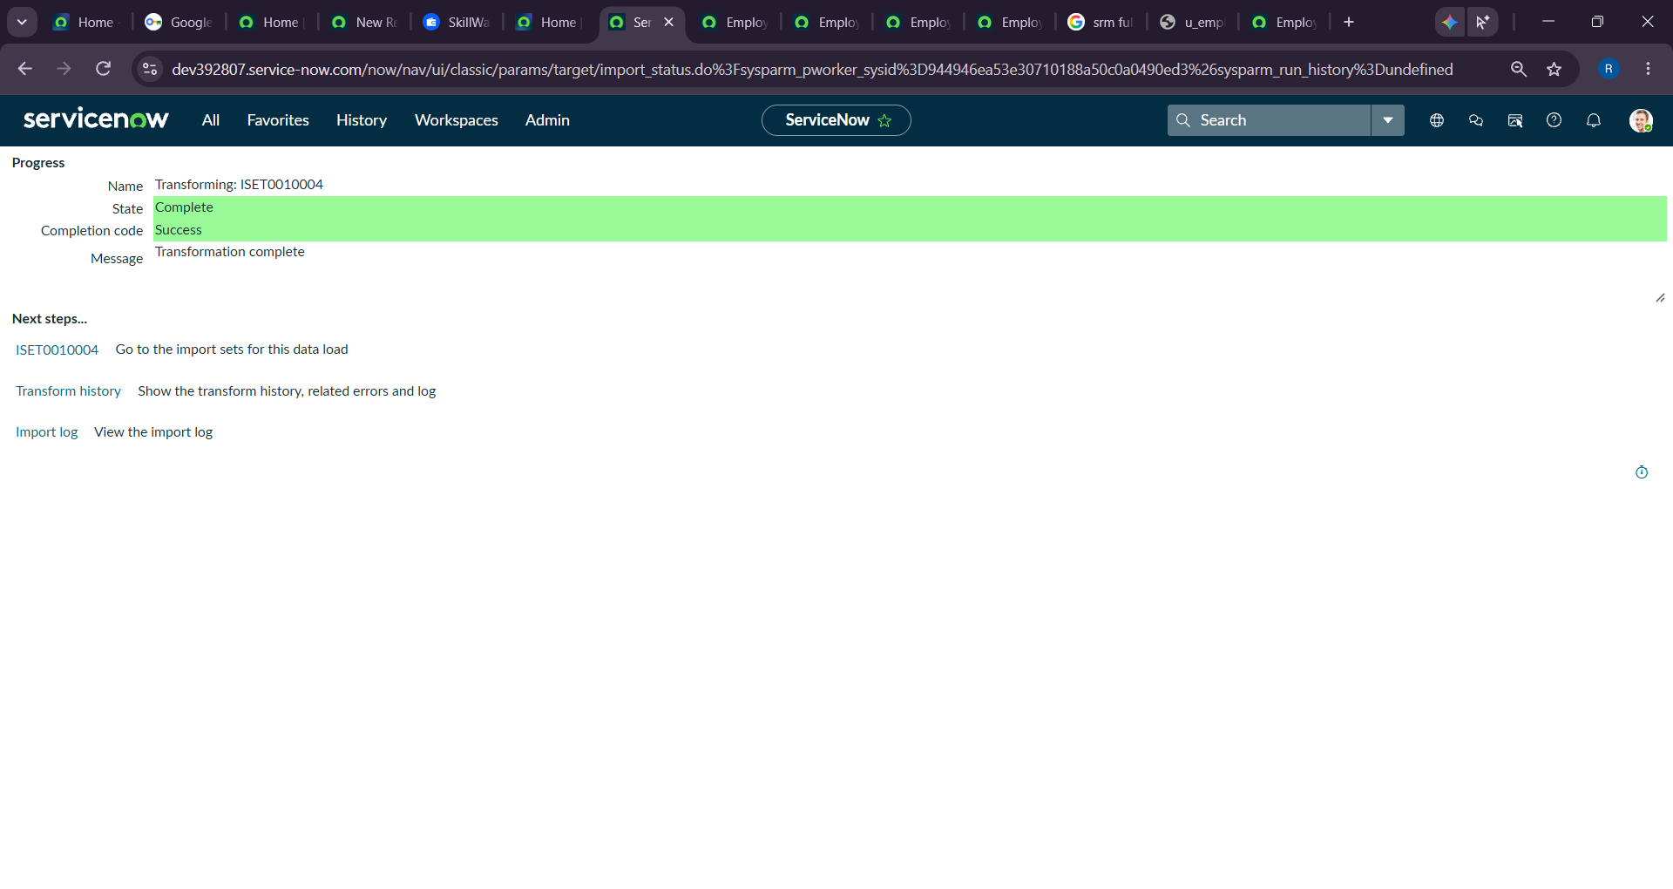
4. Transform History showing the first import results.
5. Employee Test table showing inserted/updated records.
6. Transform History for the repeated import.
7. Employee Analytics Dashboard with the completed reports.
